Breast Cancer Genetic Panel Testing

Training Document

01 July 2022
Version 1

Training Document Contents

1. Introduction 2
2. Protocol flowchart 2
3. Frequently asked questions 2
4. APPENDICES 2
4.1– Pre-test patient information leaflet 2
4.2 – Genetic Test Request Form 2
4.3 – Result letter A example – no mutation identifed 2
4.4 – Result letter B example – pathogenic or likely pathogenic mutation 2
4.5 – Result letter C example – variant that requires further evaluation 2

MCG GRL1

1. Introduction

Up to 10% of breast cancers are thought to, at least in part, have a hereditary cause. Germline mutations in specific genes, such as BRCA1 and BRCA2, are identified in around 5% of breast cancer cases. Identifying germline mutations is increasingly impacting on treatment and surgical options. Additionally, identifying a genetic cause for the cancers in a family enables identification of other family members at risk.
As you will have hopefully now watched the videos on (insert hyperlinks)
- Genetic Testing for Patients with Breast Cancer (eligibility, processes, consenting and practical aspects of sending samples)

- Germline Breast Cancer Panel Genetic Testing in Scotland (detailed information on the current genes included in the Breast Panel)
You should have a good understanding of the role of the breast cancer team in providing patients with genetic testing.
You will find in this document, the Current Process Flowchart, Frequently Asked Questions and additional relevant documents in the Appendices.

2. Protocol flowchart

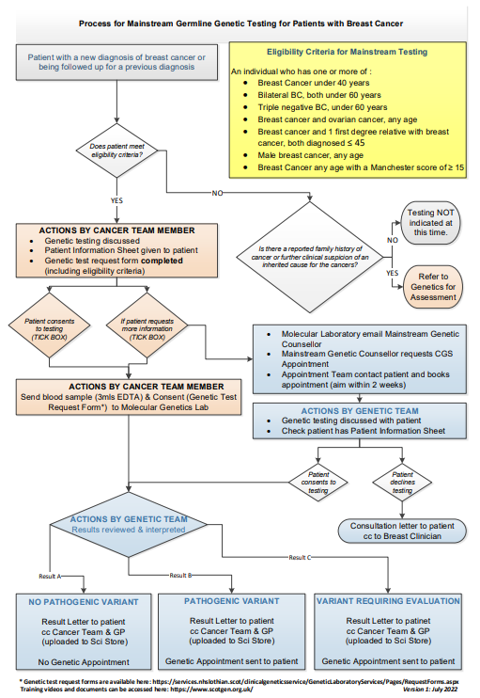

3. Frequently asked questionsMCG GRL1
Which patients can have breast cancer genetic panel testing?
Non-geneticists can only undertake testing in breast cancer (BC) patients that fulfil one or more of the following criteria.
NHS patient with:
- Breast Cancer under 40 years
- Bilateral BC, both under 60 years
- Triple negative BC, Under 60 years
- Breast cancer and ovarian cancer, any age
- Breast cancer and 1 First Degree Relative with breast cancer, both 45 years
- Male breast cancer, any age
- Manchester score of 15 or more*
*Manchester score is used to factor in family history. More advice is provided later in the document however, you may wish to contact Clinical Genetics for advice regarding eligibility.
Referrals and queries about whether or not patients are eligible should be directed to wgh.clinicalgenetics@nhslothian.scot.nhs.uk
Which non-geneticists can perform genetic testing in eligible patients?
Non-geneticists who are registered healthcare professionals and feel competent in consenting for genetic testing can request testing. Training materials have been developed to support competency development (this document, videos and patient information leaflet).
How does my patient get testing if I do not feel confident in taking consent for this test?
Any patient eligible for testing can be referred directly to the Clinical Genetics Service where an appointment will be arranged with a Genetic Counsellor. However, please be aware that this will increase the wait time for results by, on average, 5 weeks. However, to minimise the patient’s wait for results you can take a blood sample and ask the patient to select the “I consent to my sample being stored until I am contacted by Clinical Genetics” option on the Genetic Test Request Form This will prompt a Genetic appointment to be arranged to discuss testing and obtain consent.
What if my patient has further questions about the testing that I cannot answer?
Please refer any patient with additional questions to the Clinical Genetics Service and an appointment will be arranged. Alternatively, the patient can contact the Duty Genetic Counsellor directly. The contact details are available on the Genetic Testing for People Affected by Breast Cancer (Appendix 4.1) leaflet. As above, to minimise the patient’s wait for results you can take a blood sample and ask the patient to select the “I consent to my sample being stored until I am contacted by Clinical Genetics” option on the Genetic Test Request Form (Appendix 4.2).
How were the eligibility criteria for breast cancer patients decided?
The current testing eligibility criteria were evaluated as part of the Edinburgh Mainstreaming Breast Cancer Testing Pilot.
What is the testing eligibility for private patients?
Any private patient with breast cancer who meets the described criteria and are eligible for NHS care can have NHS genetic testing. Alternatively, they can be referred for testing through a private company (e.g. www.genehealthuk.com).
How strict are the age cut-offs for testing?
These are strictly applied. For example, a woman with bilateral breast cancer diagnosed at 58 years and 60 years (and no family history) would not be eligible for testing, but if she were diagnosed at 58 years and 59 years she would be eligible. It is recognised, and inevitable, that individuals close to a threshold may have similar likelihoods of carrying a mutation but different eligibility. It is important for clinicians and patients to have confidence that criteria are being consistently applied.
If you think a patient is not eligible but might be eligible on the grounds of family history, the patient can be referred to the Clinical Genetics Service for assessment. Please explain that you are referring the patient to find out if they are eligible for testing.
How is triple-negative breast cancer defined?
For the purpose of eligibility for genetic testing a triple-negative breast cancer is defined as a tumour with an Allred score of 0, 1 or 2 for ER and PR receptors and HER2 negativity by IHC or FISH.
Should in situ breast cancer be included?
In situ cancer, such as DCIS (ductal carcinoma in situ) and LCIS (lobular carcinoma in situ), should be included in the same way as invasive breast cancer in assessing eligibility for testing.
How should multiple metachronous ipsilateral breast cancers be assessed?
Two (or more) separate, ipsilateral breast cancers which have occurred 5 or more years apart should be considered as separate cancers (i.e. counted as a bilateral breast cancer) when assessing eligibility for breast panel genetic testing, unless it is clear that the second cancer is a recurrence. This is a pragmatic approach as it is not possible to robustly identify which are separate cancers and which are recurrences.
How should multiple synchronous ipsilateral breast cancers be assessed?
Simultaneous ipsilateral breast cancers, whether termed synchronous, multicentric or multifocal, should be counted as a single breast cancer for assessing eligibility for genetic testing.
What is the Manchester score?
The Manchester score is a scoring system that assesses an individuals diagnosis and their family history for the likelihood they have a germline mutation in BRCA1 or BRCA2. A Manchester score of 15 or more is estimated to equate to a 10% probability of carrying a pathogenic mutation in BRCA1 or BRCA2 and is the agreed testing threshold in the UK. Detailed information on the Manchester scoring system can be read in the following paper: https://pubmed.ncbi.nlm.nih.gov/28490612/
The basic Manchester scoring system is shown below:
Cancer, age at diagnosis | Score
Female Breast Cancer, <30 | 11
Female Breast Cancer, 30-39 | 8
Female Breast Cancer, 40-49 | 6
Female Breast Cancer, 50-59 | 4
Female Breast Cancer, >59 | 2
Male Breast Cancer, <60 | 13
Male Breast Cancer, >59 | 10
Ovarian Cancer, <60 | 13
Ovarian Cancer, >59 | 10
Pancreatic Cancer | 1
Prostate Cancer, <60 | 2
Prostate Cancer, >59 | 1

If there is any doubt over the diagnoses in a family, then a referral should be made to clinical genetics who can confirm details with the Cancer Registry if necessary.

When should discussion of genetic testing be undertaken?
This should be at the discretion of the clinician. Genetic testing can be discussed and undertaken at the time of diagnosis, during active cancer management or during follow up. However, please be aware that the lab result usually takes 8-10 weeks from receipt of sample, so if the result is required for management decisions, timing of testing must be planned accordingly.
NHS Scotland genetic testing resources are limited (e.g. lab staff and equipment) and shared across the needs of all genetic conditions and health specialties. Accessing genetic analysis in a timely manner is important to all. As a result, we request that you ONLY request the 4 week turn around where there is need for immediate management decision making.
What information should I give to the patient prior to obtaining consent?
The Genetic Testing for People Affected by Breast Cancer should be given to the patient. Patients should be informed that germline mutations in breast cancer genes are a cause of cancer and knowing whether a germline mutation is involved in causing their cancer can be helpful for their current and future management. The clinician may like to describe the specific relevance of the test for the specific patient. The patient should also be aware that the result can provide information of relevance to the wider family. However, it is important to remember that most tests are normal and therefore detailed discussions regarding risk management for patient and relatives, prior to testing, are not required.
The Genetic Test Request Form includes a list of discussion points to cover pre-test thereby providing an aid memoire for clinicians.
If a patient has questions that require either more time or more expertise than you can provide, the patient should be referred to Clinical Genetics.
What are the insurance implications for cancer patients?
If a cancer patient applies for life cover, critical illness or income protection cover after the gene test is performed, then it will need to be disclosed, along with the other information about their cancer diagnosis. This is unlikely to have impact on the cover/terms they are offered over and above the impact of their cancer diagnosis.
If the gene test was performed after an insurance policy was set-up the result does NOT need to be disclosed.
Are there insurance implications for the cancer patient’s relatives?
Relatives would need to tell the insurance company about the cancer diagnosis in the family and if a gene mutation has been found when asked about their family history (if they are aware of it). If the genetic test result is normal some insurance companies may take this into consideration to mitigate the unfavourable impact of the family history on the policy.
Unaffected individuals do not have to disclose their personal results of predictive gene testing to insurance companies but may choose to do so, particularly if they have not inherited the mutation known to be present in the family.
Which consent and lab form should I use?
For patients with breast cancer, there is a specific Genetic Test Request Form which is different from the standard genetic testing form for NHS Lothian. This combines the consent form, test criteria and request form for ease of use. Once completed, a copy of the request can be scanned to the TrakCare record or a note put in the patient electronic records to show that the genetic test has been requested. The request sheet should be sent with the patient’s labelled blood sample (1 x 3ml EDTA) to the Molecular Genetics Lab, South East Scotland Genetic Service, Western General Hospital, Crewe Road, Edinburgh, EH4 2XU.
How long does it take to get a result?
The results of full analysis typically take about 8-10 weeks. However, it may take 4 weeks if ‘urgent’ testing is requested due to immediate management decisions. For more information see FAQ section ‘When should discussion of testing be undertaken?’
If there is a known mutation in the family the result takes 2-4 weeks and would require that you had referred the patient to the Clinical Genetics Service.
Q: What genes will be analysed / tested?
The current genes tested on the germline breast cancer panel are BRCA1, BRCA2, TP53, PTEN, STK11, PALB2, ATM, CHEK2, RAD51C and RAD51D. In the future, testing for additional genes related to cancer may become available in some cases. However, this is not likely within the next 5 years.
If the patient has had multiple other cancers or if there is family history that you are concerned about, the patient can be referred to the Clinical Genetic Service.
Q: What if a patient meets the criteria but chooses not to have a test?
The test is optional. A patient may decline to be tested, ask to have longer to think about testing or be referred to Clinical Genetics if they want, or need, more detailed discussions. If the patient does not wish to have testing but would like to put a DNA sample into storage in case this is useful for their relatives in the future, please make this clear on the Genetic Test Request Form.
Q: What if a patient does not meet the testing criteria but wants a test?
Patients who do not meet the mainstreaming testing criteria may be eligible for a test on account of their family history (Manchester Score). If this seems possible, they should be referred to the Clinical Genetic Service for an appointment and a full assessment. Please note, acceptance of the referral by Clinical Genetics DOES NOT indicate that testing will be performed.
Queries about whether or not patients are eligible should be directed to mailto:WGH.ClinicalGenetics@nhslothian.scot.nhs.uk. Alternatively, they could choose to have the test privately by a private company.
What if my patient or a member of their family has already had genetic testing?
If a member of the family has already had a genetic test for genes associated with cancer predisposition, please contact the Genetics unit on mailto:WGH.ClinicalGenetics@nhslothian.scot.nhs.uk and note this (preferably including the relative’s name and date of birth) on the lab form. It may influence the testing that is performed. Please refer the patient to the Clinical Genetic Service, who will get in touch to verify the specifics in the relative.
If the patient themselves has previously had genetic testing, the Clinical Genetics Service will need to verify if this testing was undertaken to the same standard as current testing. If not, the testing may need to be repeated.
Who will give the patient the result of the test?
The Clinical Genetic Service will write to the patient with the result. The referring clinician and GP will also be notified. The result correspondence will be uploaded to the SCI Store section of NHS Lothian TrakCare, where NHS Lothian Clinical Genetics Service routinely upload their correspondence. The details will also be stored in the separate NHS Lothian Clinical Genetics Service records.
What happens if no mutation is identified?
The Clinical Genetics Service will inform the patient of the result in writing by letter, including an information sheet (Appendix 4.3). A copy result letter will be sent to the Breast Care Team (Oncologist and/or Breast Surgeon) and GP and it will be uploaded to SCI Store if the patient is registered for NHS Lothian TrakCare.
You should use the result as appropriate for their cancer management, but usually no further input is required from Genetics. If the patient has additional questions about the result, they can be referred to the Clinical Genetics team.
Please note, patients and their relatives may still be eligible for enhanced mammographic surveillance on account of their family history. Relatives can seek advice about enhanced screening via their GP.
What happens if a mutation is identified?
The Clinical Genetics Service will inform the patient in writing by letter, including an information sheet (Appendix 4.4). A copy result letter will be sent to the Breast Care Team (Oncologist and/or Breast Surgeon) and GP and it will be uploaded to SCI Store if the patient is registered for NHS Lothian Trakcare. An appointment for the Genetics clinic will also be sent for the near future.
The Cancer team should use the information as appropriate for their cancer management. The Genetics team will discuss with the patient the implications for their future cancer risk and will also evaluate which relatives may be impacted.
What if there is a variant requiring evaluation (VRE) identified?
Very occasionally (<1%), we identify a variant that does not fulfil the criteria for pathogenic mutations, where further evaluation might be possible. In such cases, the Clinical Genetics Service will inform the patient in writing by letter, including an information sheet (Appendix 4.5). A copy result letter will be sent to the Breast Care Team (Oncologist and/or Breast Surgeon) and GP and it will be uploaded to SCI Store if the patient is registered for NHS Lothian TrakCare. An appointment for the Genetics clinic will also be sent for the near future where the result will be discussed with the patient.
Q: What if there is an equivocal result?
No equivocal reports are issued. The Molecular Genetics laboratory reviews all results, determines the pathogenicity of any identified sequence variants, and interprets their clinical relevance. We have a sophisticated clinical and bioinformatic interpretative system that allows us to do this. The reports thus include clear information about whether a pathogenic mutation was identified. Very occasionally (<1%), there are sequence variants that do not fulfil the criteria for pathogenic mutations, but merit further evaluation (see above).
Q: What if the test fails?
Very occasionally, testing fails as the laboratory are not able to extract suitable DNA from the patient’s sample. This is more likely to happen in a patient undergoing chemotherapy. In this case, the laboratory will request a repeat sample.
What if new evidence in the future shows a variant is pathogenic?
If further information becomes available and any variants are reclassified, the genetics laboratory will re-issue reports. It is important to remember that rare sequence variants in these genes are collectively common in the general population (present in about 10%), and the great majority are not pathogenic.
If a mutation is identified who will follow-up the patient’s relatives?
The Clinical Genetic Service will give the patient “To whom it may concern” letters to give to relatives. The letter will explain that a cancer predisposition gene mutation has been identified in the family and that relatives can ask their GP to refer them to their local genetics service to discuss the implications. Genetic Services will NOT approach family members directly. This is standard practice in Clinical Genetics.
If the patient does not have a mutation, are there additional genetic tests that should be performed?
Some patients may be eligible for further tests, particularly if they have multiple primary cancers or if there is an extensive family history of cancer. We recommend that such patients are referred to Clinical Genetics.
Who should I contact if I have any questions or suggestions?
These should be addressed to WGH.ClinicalGenetics@nhslothian.scot.nhs.uk. We get many referrals and enquiries to the service about hereditary cancer. It would be helpful to identify when emailing if your question or comment relates to Germline Breast Cancer Genetic Testing. .
If there is anything that you would like further clarity about, please contact: mailto:WGH.ClinicalGenetics@nhslothian.scot.nhs.uk

4. APPENDICES

4.1– Pre-test patient information leaflet - EXAMPLE

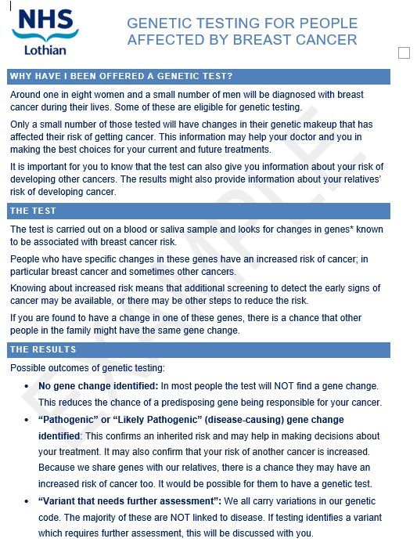

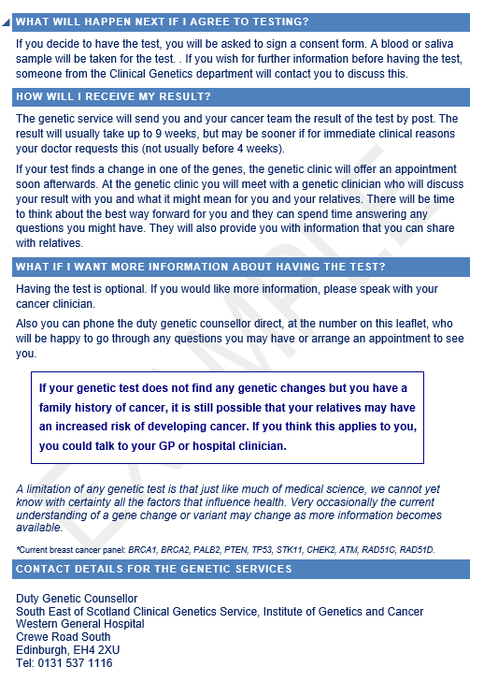

4.2 Appendix 2 – Lab request form - EXAMPLE

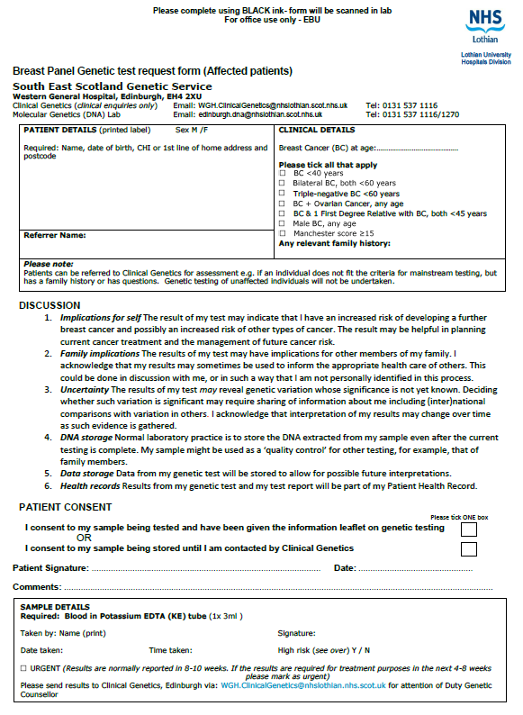

4.3 – Result letter A – no mutation identified (EXAMPLE)

Dear Patient
You will remember that you provided a blood sample so that our laboratory could look for changes in the genes known to be associated with breast cancer predisposition (BRCA1, BRCA2, PALB2, PTEN, STK11, TP53, ATM, CHEK2, RAD51C and RAD51D).

We now have the result of the analysis of these genes and the laboratory has not found any disease causing changes.

The probability that a high risk gene is the explanation for your cancer development has been reduced.
Very occasionally the current understanding of a gene variant may change as more information becomes available.
An information sheet is enclosed, providing further details about your results. A copy of this letter has been sent to your Breast/Oncology team and GP so as they are aware of this result.

If you would like an appointment to go over your results, please call the Appointments Secretary on 0131 537 1266 and request an appointment code D. The appointment line is open Tuesday 9.00am to 12.30pm and Wednesday to Friday 1.00pm – 4.30pm. Alternatively, I would be able to speak to you on the telephone on 0131 537 1116.
With best wishes

Yours sincerely

Genetic Counsellor
GCRB Registered

c.c. GP
Breast surgeon
Oncologist

RECEIVING A NORMAL BREAST GENE PANEL TEST RESULT
You had a breast gene panel test because you have had cancer.
The test result is normal.
No mutation (gene change) was identified in your blood sample. The following genes were tested: BRCA1, BRCA2, PALB2, PTEN, STK11, TP53, ATM, CHEK2, RAD51C, RAD51D.
What does this result mean for me?
This means we have not found a mutation which would put you at high risk of developing another new cancer. The cancer team will discuss if this normal result has any implications for your cancer management.
A normal result is common. In most people with breast cancer no mutation in is found. If you have a strong family history of breast and/or ovarian cancer, or a strong family history of other cancers, or if you developed cancer at an unusually young age, it may be helpful to look into things further. You can ask for a referral to the Clinical Genetics Service if you have questions or concerns about this.
Very occasionally mutations in other genes can be involved in causing breast cancer. Also new discoveries are being made all the time. Your sample is stored in case further gene testing is requested in the future.
What does this result mean for my relatives?
This result is good news for your relatives, as it means they are unlikely to be at high increased risk of developing breast cancer themselves. You may wish to share this result with them.
All women are eligible to have mammograms from 50 years in the National Breast Screening Program. Depending on the family history, some women may be eligible for mammograms from 35 or 40 years, even if there has been a normal breast gene panel test in the family.
There is currently no known effective form of ovarian screening. If a woman has multiple relatives with ovarian cancer, removal of the ovaries is sometimes considered.
If you have had a different cancer previously, or if you have a family history of cancer, it is still possible that your relatives may have an increased risk of developing cancer. If you think that this applies to you, you can talk to your GP or hospital clinician.
If any of your relatives wish to discuss their own risks of cancer further they should speak with their GP who can refer them for further discussions at a Genetics clinic.
If you have any further questions, please contact the Edinburgh Clinical Genetics Service on 0131 537 1116.

4.4 – Result letter B example – pathogenic or likely pathogenic result

Dear Patient
You had a test to look for changes in the Breast Cancer panel of eight genes. This letter is to inform you of the result of this test.
The test has identified a mutation (change) in the BRCA1 gene. This result may have implications for your cancer treatment and/or follow-up. It also has implications for your future health and may have implications for your relatives.
We have enclosed an information sheet which provides some basic information.
I have arranged an appointment for you with the Clinical Genetics service to discuss the issues in more detail as per the enclosed appointment letter.

After your appointment with Clinical Genetics we will provide you with a letter to give to other family members so they can arrange an appointment to discuss testing, should they wish to.
Yours sincerely,
Genetic Counsellor
GCRB Registered

c.c. GP
Oncologist
Breast Surgeon

RECEIVING A BREAST PANEL GENE TEST RESULT THAT IDENTIFIES A MUTATION (GENE CHANGE)
You had a Breast Cancer gene test because you have had cancer.
The test result has shown that you have a mutation (gene change) in either the BRCA1 or BRCA2 gene.
BRCA1 or BRCA2 mutations result in increased risks of breast and ovarian cancer, and occasionally other cancers. Therefore this result provides an explanation for why you developed cancer.
Your cancer team will discuss with you if this result has implications for your cancer treatment and/or follow-up.
This result has implications for your future health and potentially for your relatives. An appointment is being made for you in the Genetics clinic to discuss these issues further. You will receive a separate appointment letter about this. At the appointment you will be able discuss your future risks of cancer, your options for cancer screening and measures to reduce the risk of cancer. The potential implications for relatives will also be discussed. The processes by which your relatives can have discussions themselves to decide if they wish to have testing will be explained.
You may find it helpful to read the information booklet “A Beginner’s Guide to BRCA1 and BRCA2” which gives more detailed information. This can be downloaded from The Royal Marsden website in their Patient Information Library. This can be accessed here: https://patientinfolibrary.royalmarsden.nhs.uk/brca1brac2
If you need to discuss anything urgently prior to your appointment, or wish to alter the date of your appointment, please contact the Edinburgh Clinical Cancer Genetics Service on 0131 537 1116.

4.5– Result letter C example – variant that requires further evaluation

Dear Patient
You had a test to look for changes in the breast cancer genes. This letter is to inform you of the result of this test.
No disease-causing changes were identified in the genes, BRCA1, BRCA2, PALB2, PTEN, STK11, TP53, ATM, CHEK2, RAD51C or RAD51D. This result does not completely rule out the possibility of a genetic component.

The probability that a high risk gene is the explanation for your cancer development has been reduced.

However, we did find a change in your BRCA1 gene which we call an “unclassified variant”. This is not an uncommon event when looking at many genes. We do not currently have sufficient knowledge to know whether this change is significant in the development of cancer or just natural variation. We would not offer other family members a genetic test based on this result.

Nevertheless, it can sometimes be useful to see if any other family members who have been diagnosed with cancer carry the same gene variant to build our understanding. I have arranged an appointment for you with the Clinical Genetics service to discuss the issues in more detail as per the enclosed appointment letter.
If this appointment is not suitable please contact the Appointments Secretary on 0131 537 1266 to reschedule. The appointment line is open as follows:
Tuesday 9 – 12.30 pm
Wed to Friday 1.00pm and 4.30 pm
After your appointment with Clinical Genetics we will provide you with a letter to give to other family members so they can arrange an appointment to discuss testing, should they wish to.
Yours sincerely,
Genetic Counsellor
GCRB Registered
c.c. GP
Oncologist
Surgeon

